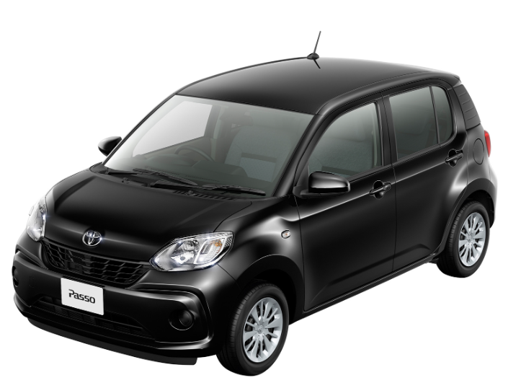

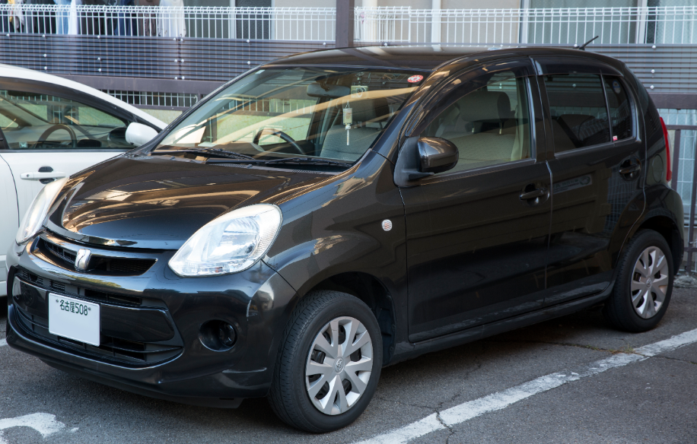

### Main Specification of Toyota PASSO🔧 Powertrain & Performance

* **Engine**: 1.0 L inline‑3 (1KR‑FE) petrol, DOHC, EFI — **68 hp @ 6,000 rpm**, **92 Nm torque @ 4,400 rpm**
* **Transmission**: CVT automatic (1-speed)
* **Drive**: Front-wheel drive
* **Top Speed**: ~180 km/h

**⛽ Fuel Efficiency**

* **City**: ~24 km/L
* **Highway**: ~28 km/L
* **Combined/WLTP**: ~21–28 km/L (depending on test cycle)

**📏 Dimensions & Weight**

* **Length**: 3,650 mm
* **Width**: 1,665 mm
* **Height**: 1,525 mm
* **Wheelbase**: 2,490 mm
* **Ground Clearance**: 150 mm
* **Kerb Weight**: ~910 kg

**🧰 Capacity**

* **Seating**: 5 passengers
* **Boot Space**: ~225–250 L (varies by model)
* **Fuel Tank**: ~36–38 L

**🛠 Chassis & Ride**

* **Suspension**: Front MacPherson strut; rear torsion beam
* **Steering**: Electric rack-and-pinion; tight turning radius ~4.6 m
* **Brakes**: Front discs; rear drums

**🛡 Safety & Features**

* Standard: ABS, ESC, dual front airbags, ISOFIX
* Available ADAS: Toyota Smart Assist II — lane departure, collision avoidance, auto-braking
* Additional options (mainly in Moda trims): rear camera, parking sensors, LED lights

**💸 Pakistan Market Highlights**

* **Price range**: PKR 3.3 – 3.8 million depending on trim
* **Popular trims**: X, Moda, X L package, Moda S, X G

**📝 Quick Snapshot**

| **Feature** | **Details** |
| --- | --- |
| Engine | 1.0 L I3, 68 hp / 92 Nm |
| Transmission | CVT automatic |
| Fuel Efficiency | 24–28 km/L |
| Dimensions (L×W×H) | 3650×1665×1525 mm |
| Wheelbase | 2490 mm |
| Weight | ~910 kg |
| Boot Volume | ~225–250 L |
| Safety | ABS, ESC, airbags, Smart Assist II |
| Price (PKR) | 3.3–3.8 M |

**💡 Community Insights**

Reddit users often praise the Passo’s spacious feel and smooth ride in city driving:

“Toyota Passo ... very comfortable city car. Japanese made ... maintenance is slightly higher than locally manufactured, however, it's still cheap.”